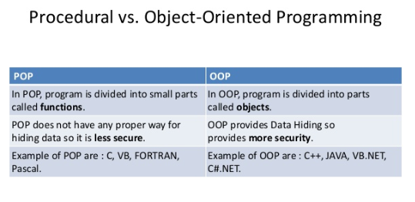

POP Feature:-

1. Importance is on Algorithm.

POP Disadvantage: Data Security

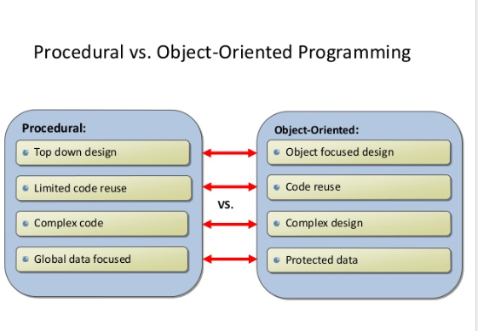

The first major procedural programming languages first appeared circa 1960, including Fortran, ALGOL, COBOL and BASIC. Pascal and C were published closer to the 1970s.

The first major object-oriented programming language built from the ground up is Java in 1995.